**Booking a training session via Clearing House online**

When you log into Clearing House and scroll down on your home page, you will see a section with the heading ‘Book a team member onto training’:

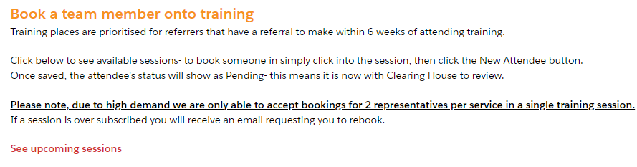

Click ‘See upcoming sessions’ to see available sessions that are appropriate for members of your team:

3

2

1

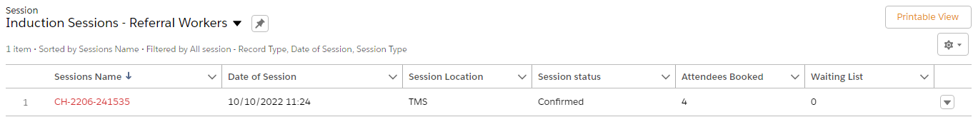

1. Click into the session name if you would like to make a booking
2. TMS = St Mungo’s, 3 Thomas More Square, Tower Hill, London E1W 1WY
3. This shows the number of people currently confirmed on the session (there may be more pending approval from the Clearing House team)

When you click into the session you’ll see a list of people either pending or booked onto the session. If that person is someone from your team, you’ll see their name appear in the ‘Attendee name’ list. Otherwise, you’ll see ‘Private, booked by another project’.

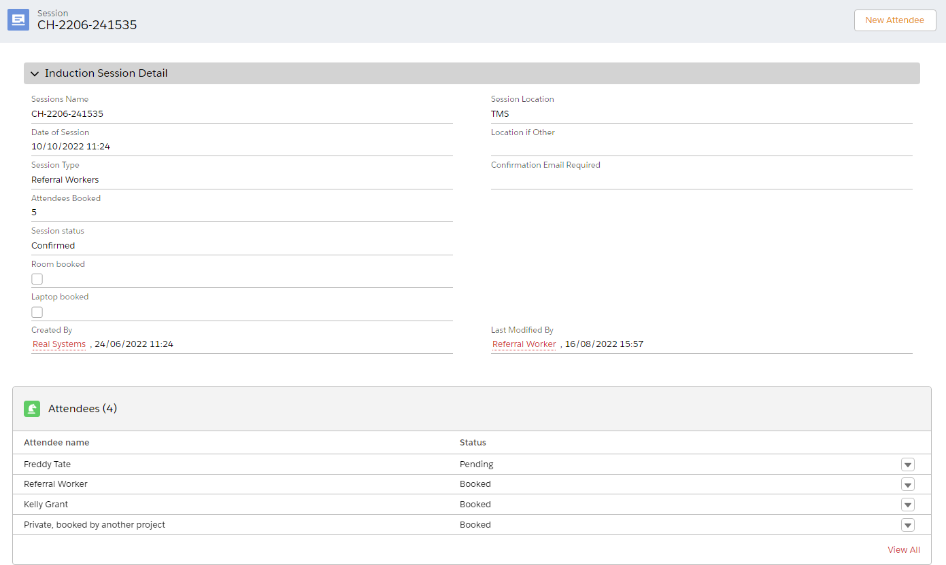

To book someone on, click the New Attendee button in the top right:



You’ll be presented with the following screen. Fill out the information and click Next:

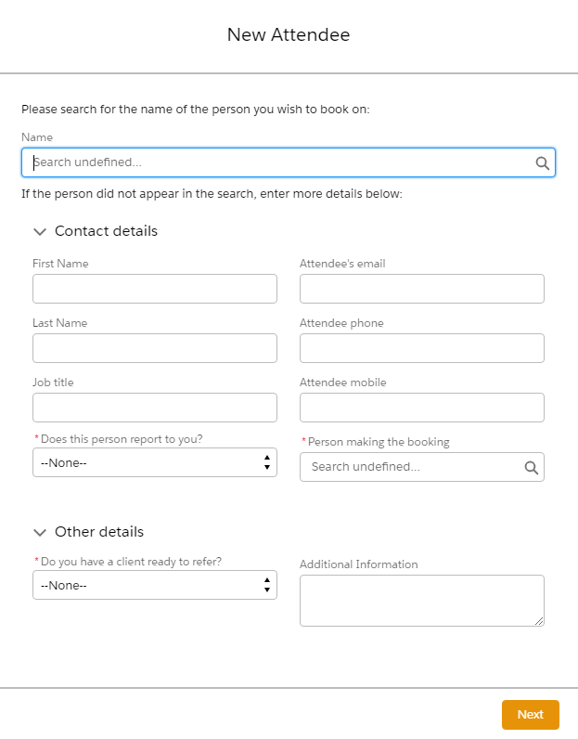

The person you have just booked on will now show at the top of the attendee list as Pending.

If the booking is approved, both you and the person who will be attending the session will receive an automated confirmation email. Otherwise you will both receive an email letting you know that we have been unable to book you onto the session at this time, or to let you know that you have been waitlisted.